Experiment 12: Implement the K-means algorithm and apply it to the data you selected. Evaluate performance by measuring the sum of the Euclidean distance of each example from its class center. Test the performance of the algorithm as a function of the parameters K.
AIM: To Implement the K-means algorithm and Evaluate performance by measuring the sum of the Euclidean distance of each example from its class center. And Test the performance of the algorithm as a function of the parameters K.
Requrement: Python IDE (Jupyter Notebook / Google Colab / PyCharm / Spyder) Python libraries: Pandas , Scikit-learn and classification dataset (Iris ) for clustering .
Procedure:
step 1: Import Required Libraries
Step 2: Load the Dataset
Step 3: Evaluate performance for K = 1 to 6
Step 4: Cluster Visualization for chosen K (K=3 here)
Step 5: Plot Performance (Elbow Curve)
Step 6: Plot Performance (Elbow Curve)Step
7: Evaluate Clustering Performance
Step 8: Test with a New Sample
from sklearn.datasets import load_iris
import numpy as np
import pandas as pd
from sklearn.cluster import KMeans
import matplotlib.pyplot as plt
# Load dataset
iris=load_iris()
df=pd.DataFrame(data=iris.data,columns=iris.feature_names)
X = df.values
# Evaluate performance for K = 1 to 6
Ks = range(1, 7)
sum_of_distances = []
for k in Ks:
kmeans = KMeans(n_clusters=k, random_state=42)
kmeans.fit(X)
sum_of_distances.append(kmeans.inertia_) # inertia = sum of Euclidean distances
# Plot Performance (Elbow Curve)
plt.figure(figsize=(8,5))
plt.plot(Ks, sum_of_distances, marker='o')
plt.xlabel("K Value")
plt.ylabel("Sum of Euclidean Distances (Inertia)")
plt.title("K-Means Performance vs K")
plt.grid(True)
plt.show()
# Print results
print("Performance Evaluation (Sum of Euclidean Distances):")
for k, dist in zip(Ks, sum_of_distances):
print(f"K={k}: {dist:.4f}")
# Cluster Visualization for chosen K (K=3 here)
best_k = 3
kmeans_final = KMeans(n_clusters=best_k, random_state=42)
kmeans_final.fit(X)
labels = kmeans_final.labels_
centers = kmeans_final.cluster_centers_
plt.figure(figsize=(8,5))
plt.scatter(df["petal length (cm)"], df["petal width (cm)"], c=labels, s=90, edgecolor='k')
plt.scatter(centers[:,2], centers[:,3], marker='*', s=300, c='red')
plt.xlabel("Petal Length")
plt.ylabel("Petal Width")
plt.title(f"K-Means Cluster Visualization (K={best_k})")
plt.grid(True)
plt.show()
new_sample = np.array([[5.2, 3.4, 1.5, 0.3]]) # change values to test any input
cluster = kmeans.predict(new_sample)[0]
sample_list = new_sample[0].tolist()
print(f"{sample_list}sample belongs to the cluster number:{cluster}")
OUTPUT:
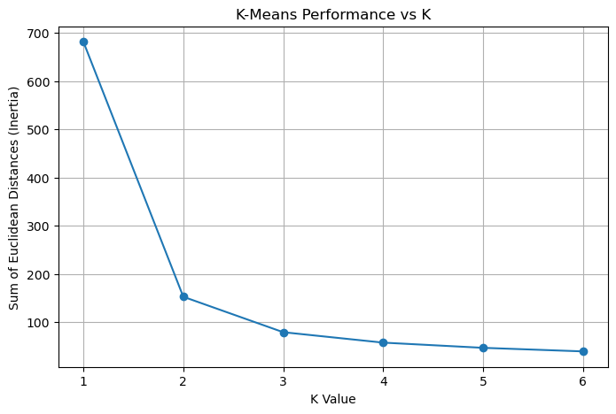
Performance Evaluation (Sum of Euclidean Distances):
K=1: 681.3706
K=2: 152.3480
K=3: 78.8514
K=4: 57.2285
K=5: 46.4462
K=6: 39.0400
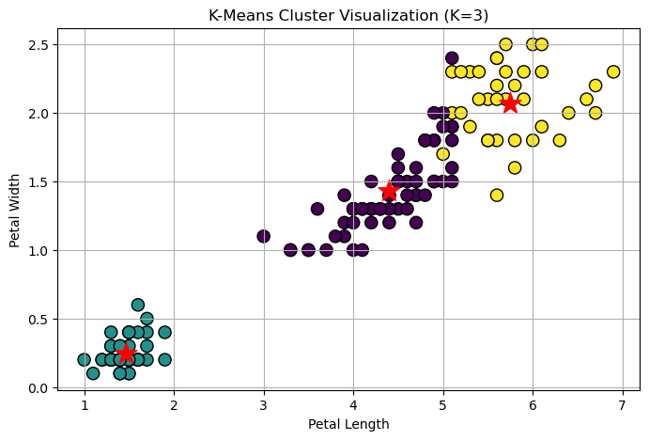
[5.2, 3.4, 1.5, 0.3]sample belongs to the cluster number:5

